Search Algorithms in AI

What is Search in AI?
In AI, search refers to the process of navigating through a problem space to find a solution. AI agents use search algorithms to make decisions or find optimal paths from a start state to a goal state.

What is Search in Artificial Intelligence?
Search, whether in AI or in general, is a step-by-step method for resolving a search problem in a specific search space. It accomplishes this by examining several aspects of the search problem, including:

1. Search Space
In the initial state of the search issue, the search space represents all of the conceivable sets of solutions that a system could have.

2. Start State
This is where the agents start their search.

3. Target Test
This is the final state of the search problem; it observes the current state of the problem space and returns whether or not the goal state has been reached.
Following the completion of these factors, the solution to the search issues is offered in the form of a plan, which transforms the start state to the target state. The role of search algorithms begins here since it aids in the execution of the plan.

What is Search Algorithm?
Whether it was ‘Deep Blue’ eliminating Gary Kasparov in chess in 1997 or ‘Alpha Go’ defeating Lee Sudol in 2016, AI’s ability to mimic and surpass human mental powers has grown tremendously.
Such Artificial Intelligence programs are built around search algorithms. While we may be tempted to believe that this is solely useful in the realms of gaming and puzzle-solving, such algorithms are employed in a wide range of AI applications, including action planning, robotics, software, autonomous driving, theorem proving, and so on.
Many AI problems can be modeled as a search problem, with the aim being to get from the original state to the destination via state transformation rules.
So, in a nutshell, the search space is a graph (or a tree), and the purpose is to get from the beginning state to the end by taking the shortest path, in terms of cost, length, etc.

AI Search Algorithm Terminologies

1. Problem Space
It is, in essence, the setting in which the search takes place. (A set of states and a set of operators for changing them.)

2. The instance of the Problem
It’s a result of the initial state plus the target state.

3. Graph of Problem Space
We utilize it to indicate the status of a situation. We also use hubs to represent states, whereas edges represent operators.

4. The gravity of a problem
The length of the shortest possible path can be determined.

5. Complexity of Space
We can calculate it as the greatest number of hubs stored in memory.

6. Complexity of Time
The greatest extreme number of hubs produced is defined.

7. Applicability
It can be described as a quality of a calculation that allows it to consistently find an optimum layout.

8. Factor of Stretching
In the problematic space diagram, we can determine it as the typical number of youngster hubs.

9. Depth
The distance between an underlying state and an objective state can be traveled in the least amount of time.

Properties of Search Algorithms
The following are the four essential qualities of search algorithms that can be used to compare the effectiveness of various algorithms:

1. Completeness
If a search method guarantees to return a solution if at least one solution exists for any random input, it is said to be complete.

2. Optimality
A solution obtained for an algorithm is considered to be optimal if it is guaranteed to be the best solution (lowest route cost) among all other solutions.

3. Time Complexity
It is a measure of how long it takes an algorithm to perform its task.

4. Space Complexity
The maximum storage capacity required at any time during the search, as measured by the problem’s complexity.

Classification of Search Algorithms
Search algorithms are mainly classified into two broad categories:

1. Uninformed (Blind) Search
- No additional information about the goal state is used.
- Only the problem definition is known.

Algorithm | Description
Breadth-First Search (BFS) | Explores all nodes at the current depth before going deeper.
Depth-First Search (DFS) | Explores as far as possible along each branch before backtracking.
Uniform Cost Search (UCS) | Expands the node with the lowest path cost.
Depth-Limited Search | DFS with a limit on how deep the recursion goes.
Iterative Deepening DFS (IDDFS) | Repeatedly applies DFS with increasing depth limits.

Pros:
- Simple to implement.
- Systematic.

Cons:
- Often inefficient.
- Time and space complexity can be high.

2. Informed (Heuristic) Search
Uses domain-specific knowledge (heuristics) to guide the search.

Examples:
Algorithm | Description
Best-First Search | Selects the most promising node based on a heuristic.
Greedy Search | Uses heuristic function h(n) to select the next node.
A Search* | Uses f(n) = g(n) + h(n) (cost + heuristic) to select optimal paths.
Recursive Best-First Search (RBFS) | Memory-efficient version of A*.
Hill Climbing | Moves in the direction of increasing value (or decreasing cost).
Simulated Annealing | Probabilistic technique to escape local minima.

Pros:
- More efficient than blind search.
- Can find optimal or near-optimal solutions.
Cons:
- Requires good heuristics.
- May be complex to implement.

Comparison Table
Feature | Uninformed Search | Informed Search
Uses heuristics | ❌ No | ✅ Yes
Knowledge required | Only problem definition | Domain knowledge needed
Efficiency | Low | Higher (with good heuristic)
Optimality | Varies (e.g., UCS is optimal) | A* is optimal and complete

Heuristic Function
- A heuristic is a function h(n) that estimates the cost to reach the goal from node n.
- It must be:
  - Admissible: Never overestimates the true cost.
  - Consistent (Monotonic): For all nodes n and successors n',
h(n) ≤ cost(n, n') + h(n').

Teaching Tip
Use visual examples (like a maze or grid map) to demonstrate:
- BFS expanding layer by layer
- DFS going deep
- A* choosing best cost + estimate path
Summary
- Search is fundamental in AI for decision-making and problem-solving.
- Uninformed search is systematic but inefficient.
- Informed search uses heuristics to improve efficiency.
- Choosing the right search algorithm depends on the problem constraints and available knowledge.

Searching Strategies : Introduction
- Searching is a process to find the solution for a given set of problems. This in artificial intelligence can be done by using either uninformed searching strategies of either informed searching strategies.

Un-Informed Search Strategy
- Un-Informed search strategy further includes two techniques. These are:
  - Breadth First Search.
  - Depth First Search.

Breadth First Search
- In Breadth First Search(BFS), the root node of the graph is expanded first, then all the successor nodes are expanded and then their successor and so on i.e. the nodes are expanded level wise starting at root level.
- For Example :

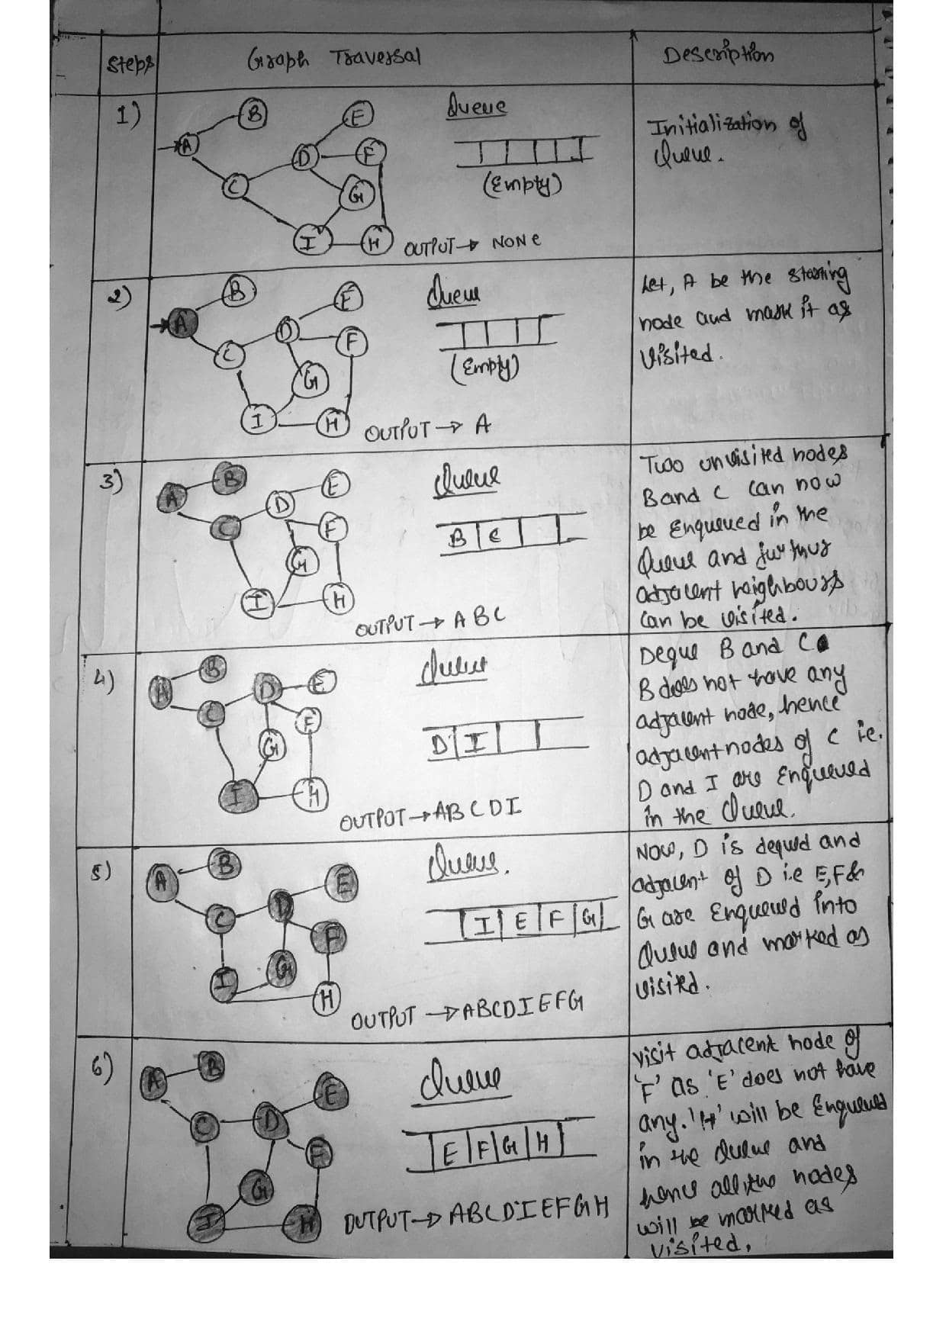
Searching Strategies : Breadth First Search

Depth First Search
- In Depth First Search(DFS), the deepest node is expanded in the current unexplored node of the search tree. The search goes into depth until there is no more successor nodes.
- For Example :

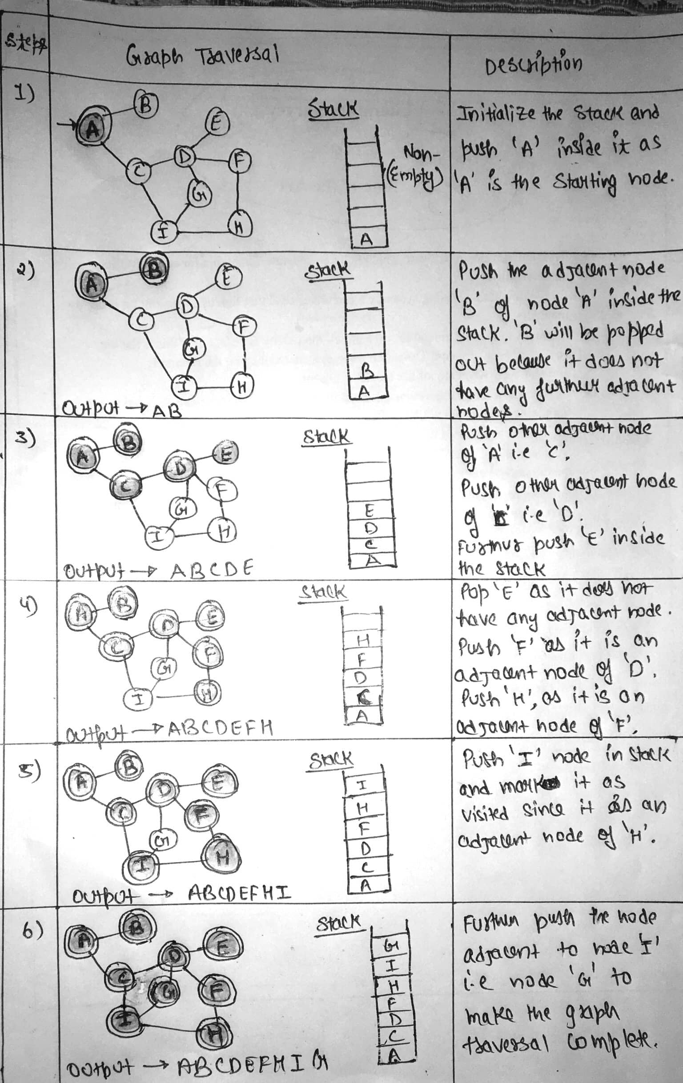
Searching Strategies : Depth First Search

Uniform Cost Search (UCS) is a search algorithm used in artificial intelligence (AI) for finding the least cost path in a graph. It is a variant of Dijkstra's algorithm and is particularly useful when all edges of the graph have different weights, and the goal is to find the path with the minimum total cost from a start node to a goal node. In this article, we will explore the fundamentals of UCS, its working mechanism, and its applications in AI.

Introduction to Uniform Cost Search (UCS)
Uniform Cost Search is a pathfinding algorithm that expands the least cost node first, ensuring that the path to the goal node has the minimum cost. Unlike other search algorithms like Breadth-First Search (BFS), UCS takes into account the cost of each path, making it suitable for weighted graphs where each edge has a different cost.

Key Concepts of Uniform Cost Search
- Priority Queue: UCS uses a priority queue to store nodes. The node with the lowest cumulative cost is expanded first. This ensures that the search explores the most promising paths first.
- Path Cost: The cost associated with reaching a particular node from the start node. UCS calculates the cumulative cost from the start node to the current node and prioritizes nodes with lower costs.
- Exploration: UCS explores nodes by expanding the least costly node first, continuing this process until the goal node is reached. The path to the goal node is guaranteed to be the least costly one.
- Termination: The algorithm terminates when the goal node is expanded, ensuring that the first time the goal node is reached, the path is the optimal one.

Working Uniform Cost Search
UCS operates under a simple principle: among all possible expansions, pick the path that has the smallest total cost from the start node. This is implemented using a priority queue to keep the partial paths in order, based on the total cost from the root node.
Here’s the step-by-step process of how UCS works:
- Initialization: UCS starts with the root node. It is added to the priority queue with a cumulative cost of zero since no steps have been taken yet.
- Node Expansion: The node with the lowest path cost is removed from the priority queue. This node is then expanded, and its neighbors are explored.
- Exploring Neighbors: For each neighbor of the expanded node, the algorithm calculates the total cost from the start node to the neighbor through the current node. If a neighbor node is not in the priority queue, it is added to the queue with the calculated cost. If the neighbor is already in the queue but a lower cost path to this neighbor is found, the cost is updated in the queue.
- Goal Check: After expanding a node, the algorithm checks if it has reached the goal node. If the goal is reached, the algorithm returns the total cost to reach this node and the path taken.
- Repetition: This process repeats until the priority queue is empty or the goal is reached.

Implementing Uniform Cost Search to Solve Pathfinding

Uniform Cost Search (UCS) Algorithm
- Use Priority Queue
- Sorted increasing order of path cost
- Guaranteed to find optimal solution.
- UCS expands node with least path cost g(n) so far

When all steps are equal, breadth-first search is optimal because it always expands the shallowest unexpanded node. By a simple extension, we can find an algorithm that is optimal with any step-cost function. Instead of expanding the shallowest node, uniform-cost search expands the node n with the lowest path cost g(n). This is done by storing the frontier as a priority queue ordered by g.
The algorithm is shown in Figure:
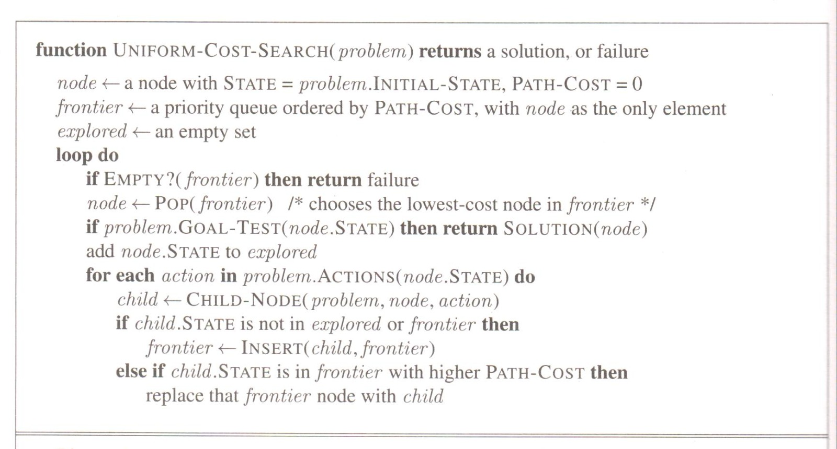

Example I:
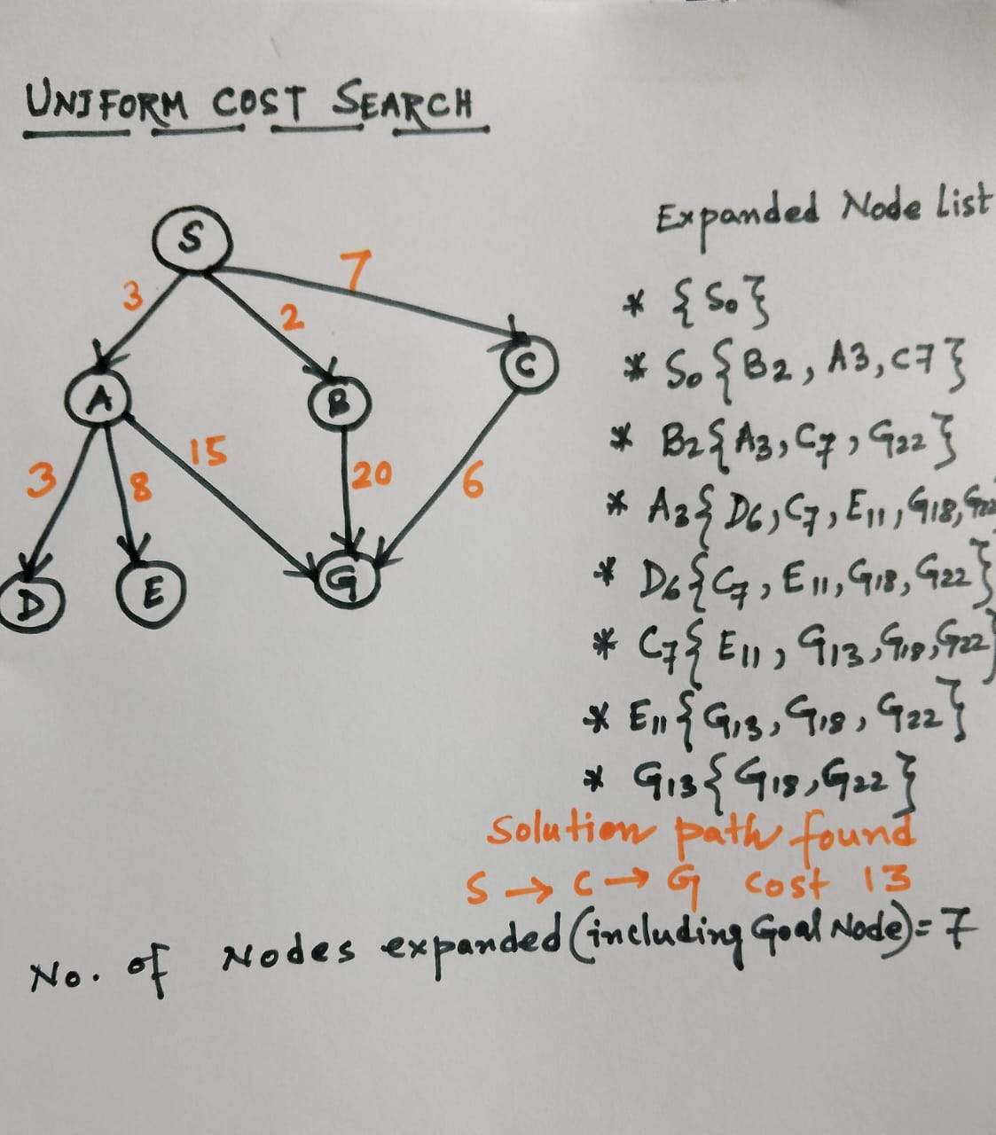

Assignment I: Solve this problem by using Uniform Cost Search Algorithm

Start Node: Arad
Goal Node: Bucharest
Find The optimal path, if any.
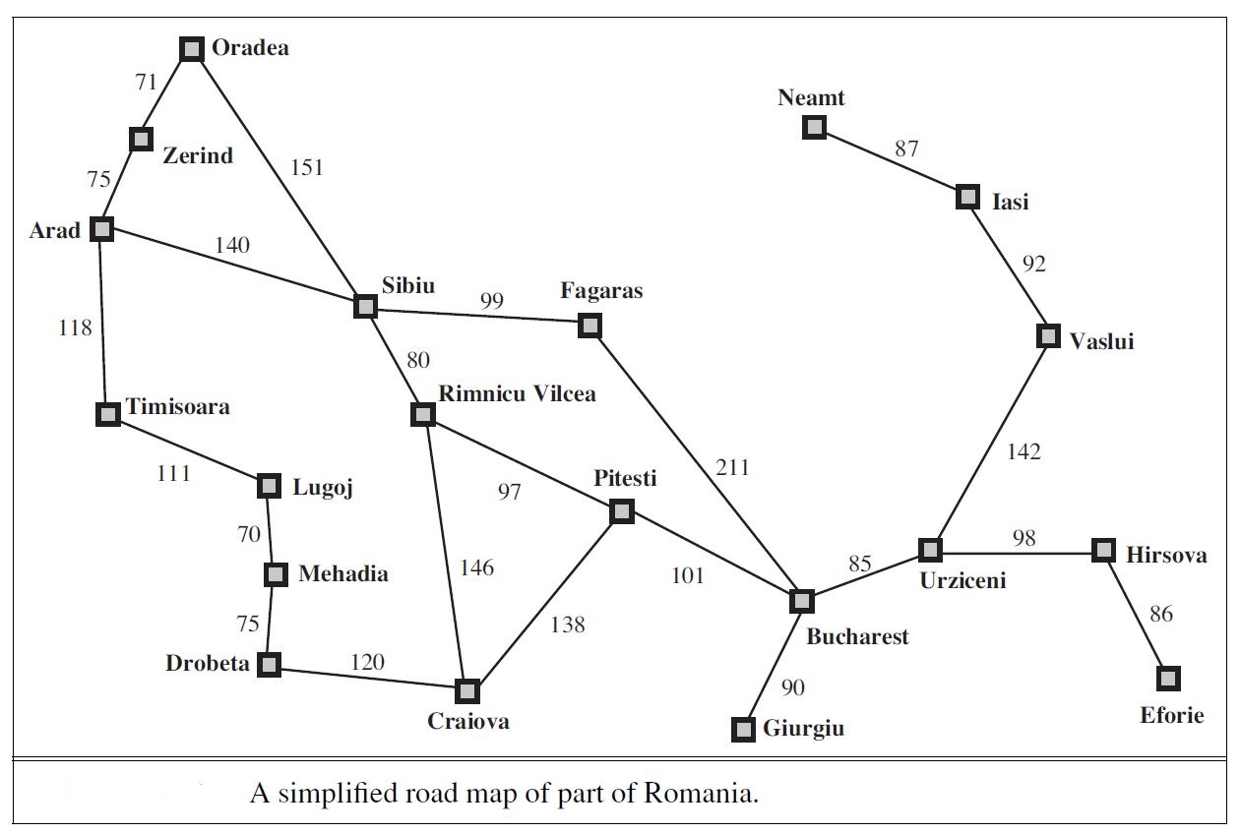

Applications of UCS in AI
Uniform Cost Search is widely applicable in various fields within AI:
- Pathfinding in Maps: Determining the shortest route between two locations on a map, considering different costs for different paths.
- Network Routing: Finding the least-cost route in a communication or data network.
- Puzzle Solving: Solving puzzles where each move has a cost associated with it, such as the sliding tiles puzzle.
- Resource Allocation: Tasks that involve distributing resources efficiently, where costs are associated with different allocation strategies.

Advantages of Uniform Cost Search
- Optimality: UCS is guaranteed to find the least cost path to the goal state if the cost of each step exceeds zero.
- Completeness: This algorithm is complete; it will find a solution if one exists.

Challenges with UCS
- Space Complexity: The main drawback of UCS is its space complexity. The priority queue can grow significantly, especially if many nodes are being expanded.
- Time Complexity: The time it takes to find the least cost path can be considerable, especially if the state space is large

Informed Search Strategy
- Informed search strategy further includes two searching techniques. These are:
  - A* Search Technique.
  - AO* Search Technique.

A* Search Technique
- A* search technique is an informal search strategy but can be called as a form of best first search.
- It is a search technique which the most optimistic node is expanded by expanding a graph.
- The node of the graph can be evaluated by using two functions i.e. g(n) and h(n).
Here,
g(n) = Cost/Distance to reach node “n”.
h(n) = Cost/Distance to reach from node “n” to the goal node.
- For evaluating any node, function f(n) is generated and used as:
f(n) = g(n) + h(n).
where,
f(n) = Estimated cost/distance of solution through node “n”.

A* Technique : Working
- In the first step, two sets are maintained:
  - OPEN SET:: It contains the set of nodes that needs to be visited/Examined.
  - CLOSED SET:: It contains the set of nodes that have already been visited or examined.
- Every individual node “n” maintains the function g(n), h(n) and f(n).
- Each node also maintains link pointer to its parent node s that the best solution can be retrieved, if found.

AO* Algorithm
- AO* algorithm is the modified version of A* algorithm in order to cover up the limitations of A* algorithm.
- The AO* uses a single structure i.e. “G”, unlike two sets OPEN and CLOSE that was used in A* algorithm.
- The structure “G” represents the part of the graph that has been generated so far.
- Each node of the structure “G” is always connected either to its immediate successor or predecessor.
- The nodes of the structure “G” also contains their respective distance/cost from each other.
- The cost between the starting node to current node “n” of structure “G” is not stored.
- Through this, AO* is always able to find solutions with minimum cost.

Breadth-First Search (BFS) | Explores all nodes at one depth before going deeper. | ✅ Yes | ✅ Yes
Depth-First Search (DFS) | Explores as far as possible down each branch. | ❌ No | ❌ No (can loop)
Uniform Cost Search | Expands the least-cost node first. | ✅ Yes | ✅ Yes
Depth-Limited Search | DFS with a depth cutoff. | ❌ No | ❌ No
Iterative Deepening DFS | Repeated DFS with increasing depth limit. | ✅ Yes | ✅ Yes

2. Informed Search (Heuristic Search)
These algorithms use heuristics to guide the search toward the goal faster.
Algorithm | Description | Optimal? | Complete?
Greedy Best-First Search | Expands the node with the lowest heuristic value (h(n)). | ❌ No | ❌ No
A* Search | Uses f(n) = g(n) + h(n) to balance cost and heuristic. | ✅ Yes (if h is admissible) | ✅ Yes
Beam Search | Like BFS, but only keeps top-k nodes at each level. | ❌ No | ❌ No

Optimization Techniques in AI
Used in planning, learning, resource allocation, etc., to find the best solution from a set of candidates.

1. Deterministic Optimization
Technique | Description
Linear Programming (LP) | Optimization of a linear objective function with constraints
Integer Programming | LP where variables are integers
Constraint Satisfaction Problems (CSP) | Variables must satisfy constraints (e.g., Sudoku)

Stochastic / Metaheuristic Optimization
Technique | Description
Genetic Algorithms (GA) | Inspired by evolution (mutation, crossover, selection)
Simulated Annealing | Probabilistic technique to escape local minima
Particle Swarm Optimization (PSO) | Inspired by bird flocking; particles explore solution space
Ant Colony Optimization (ACO) | Uses artificial 'ants' and pheromone trails to find paths

Search vs Optimization: Quick Comparison
Feature | Search | Optimization
Goal | Find a solution | Find the best solution
Domain | AI planning, pathfinding | Scheduling, ML tuning, etc.
Algorithms | BFS, DFS, A*, etc. | GA, PSO, LP, SA, etc.

Artificial Intelligence is the study of building agents that act rationally. Most of the time, these agents perform some kind of search algorithm in the background in order to achieve their tasks.
- A search problem consists of:
  - A State Space. Set of all possible states where you can be.
  - A Start State. The state from where the search begins.
  - A Goal State. A function that looks at the current state returns whether or not it is the goal state.
- The Solution to a search problem is a sequence of actions, called the plan that transforms the start state to the goal state.
- This plan is achieved through search algorithms.

Types of search algorithms:
There are far too many powerful search algorithms out there to fit in a single article. Instead, this article will discuss six of the fundamental search algorithms, divided into two categories, as shown below.
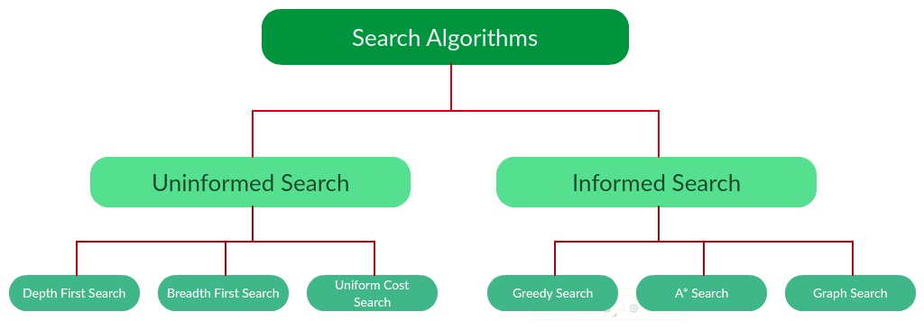
Note that there is much more to search algorithms than the chart I have provided above. However, this article will mostly stick to the above chart, exploring the algorithms given there.

Uninformed Search Algorithms:
The search algorithms in this section have no additional information on the goal node other than the one provided in the problem definition. The plans to reach the goal state from the start state differ only by the order and/or length of actions. Uninformed search is also called Blind search. These algorithms can only generate the successors and differentiate between the goal state and non goal state.
The following uninformed search algorithms are discussed in this section.
- Depth First Search
- Breadth First Search
- Uniform Cost Search
Each of these algorithms will have:
- A problem graph, containing the start node S and the goal node G.
- A strategy, describing the manner in which the graph will be traversed to get to G.
- A fringe, which is a data structure used to store all the possible states (nodes) that you can go from the current states.
- A tree, that results while traversing to the goal node.
- A solution plan, which the sequence of nodes from S to G.

Depth First Search:
Depth-first search (DFS) is an algorithm for traversing or searching tree or graph data structures. The algorithm starts at the root node (selecting some arbitrary node as the root node in the case of a graph) and explores as far as possible along each branch before backtracking. It uses last in- first-out strategy and hence it is implemented using a stack.
Example:
Question. Which solution would DFS find to move from node S to node G if run on the graph below?
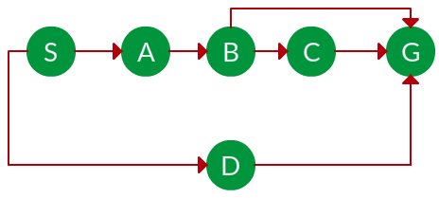
Solution. The equivalent search tree for the above graph is as follows. As DFS traverses the tree "deepest node first", it would always pick the deeper branch until it reaches the solution (or it runs out of nodes, and goes to the next branch). The traversal is shown in blue arrows.
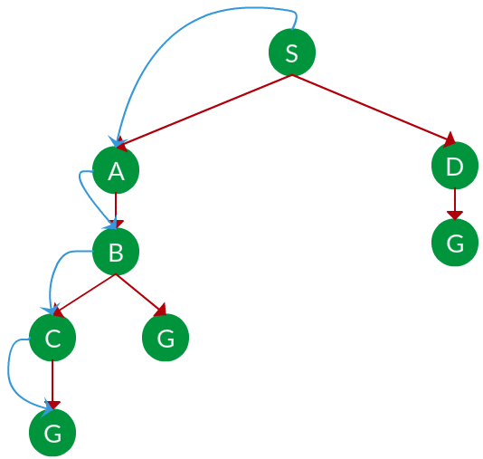
Path: S -> A -> B -> C -> G
d = the depth of the search tree = the number of levels of the search tree.
ni = number of nodes in level i i .
Time complexity: Equivalent to the number of nodes traversed in DFS. T(n)=1+n2+n3+...+nd=O(nd) T(n)=1+n2+n3+...+nd=O(nd)
Space complexity: Equivalent to how large can the fringe get. S(n)=O(n×d) S(n)=O(n×d)
Completeness: DFS is complete if the search tree is finite, meaning for a given finite search tree, DFS will come up with a solution if it exists.
Optimality: DFS is not optimal, meaning the number of steps in reaching the solution, or the cost spent in reaching it is high.

Breadth First Search:
Breadth-first search (BFS) is an algorithm for traversing or searching tree or graph data structures. It starts at the tree root (or some arbitrary node of a graph, sometimes referred to as a 'search key'), and explores all of the neighbor nodes at the present depth prior to moving on to the nodes at the next depth level. It is implemented using a queue.
Example:
Question. Which solution would BFS find to move from node S to node G if run on the graph below?
Solution. The equivalent search tree for the above graph is as follows. As BFS traverses the tree "shallowest node first", it would always pick the shallower branch until it reaches the solution (or it runs out of nodes, and goes to the next branch). The traversal is shown in blue arrows.
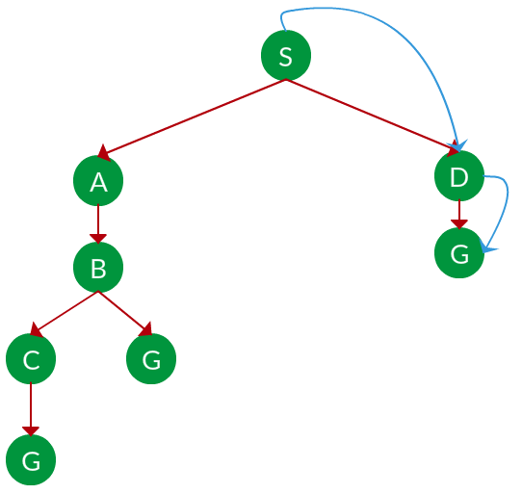
Path: S -> D -> G
s s = the depth of the shallowest solution.
ni ni = number of nodes in level i i .
Time complexity: Equivalent to the number of nodes traversed in BFS until the shallowest solution. T(n)=1+n2+n3+...+ns=O(ns) T(n)=1+n2+n3+...+ns=O(ns)
Space complexity: Equivalent to how large can the fringe get. S(n)=O(ns) S(n)=O(ns)
Completeness: BFS is complete, meaning for a given search tree, BFS will come up with a solution if it exists.
Optimality: BFS is optimal as long as the costs of all edges are equal.

Uniform Cost Search:
UCS is different from BFS and DFS because here the costs come into play. In other words, traversing via different edges might not have the same cost. The goal is to find a path where the cumulative sum of costs is the least.
Cost of a node is defined as:
cost(node) = cumulative cost of all nodes from root
cost(root) = 0
Example:
Question. Which solution would UCS find to move from node S to node G if run on the graph below?
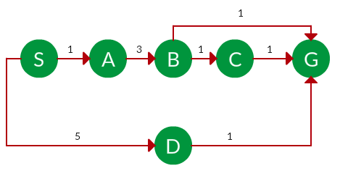
Solution. The equivalent search tree for the above graph is as follows. The cost of each node is the cumulative cost of reaching that node from the root. Based on the UCS strategy, the path with the least cumulative cost is chosen. Note that due to the many options in the fringe, the algorithm explores most of them so long as their cost is low, and discards them when a lower-cost path is found; these discarded traversals are not shown below. The actual traversal is shown in blue.
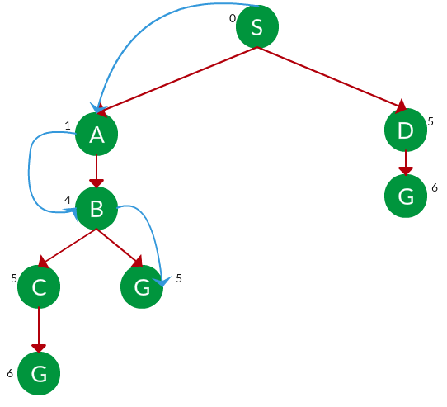
Path: S -> A -> B -> G
Cost: 5
Let C C = cost of solution.
ε ε = arcs cost.
Then C/ε= C/ε= effective depth
Time complexity: [Tex]T(n) = O(n^C ^/ ^\varepsilon) [/Tex], Space complexity: [Tex]S(n) = O(n^C ^/ ^\varepsilon) [/Tex]
Advantages:
- UCS is complete only if states are finite and there should be no loop with zero weight.
- UCS is optimal only if there is no negative cost.
Disadvantages:
- Explores options in every "direction".
- No information on goal location.

Informed Search Algorithms:
Here, the algorithms have information on the goal state, which helps in more efficient searching. This information is obtained by something called a heuristic.
In this section, we will discuss the following search algorithms.
- Greedy Search
- A* Tree Search
- A* Graph Search
Search Heuristics: In an informed search, a heuristic is a function that estimates how close a state is to the goal state. For example - Manhattan distance, Euclidean distance, etc. (Lesser the distance, closer the goal.) Different heuristics are used in different informed algorithms discussed below.

Greedy Search:
In greedy search, we expand the node closest to the goal node. The "closeness" is estimated by a heuristic h(x).
Heuristic: A heuristic h is defined as-
h(x) = Estimate of distance of node x from the goal node.
Lower the value of h(x), closer is the node from the goal.
Strategy: Expand the node closest to the goal state, i.e. expand the node with a lower h value.
Example:
Question. Find the path from S to G using greedy search. The heuristic values h of each node below the name of the node.
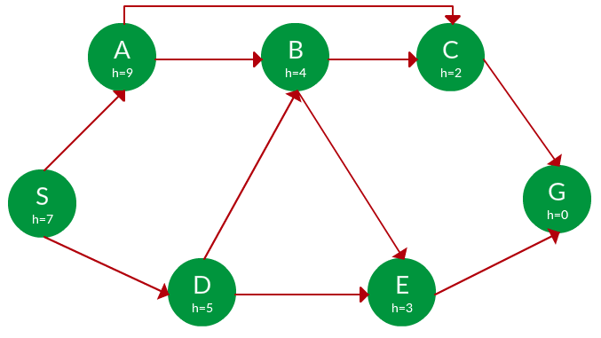
Solution. Starting from S, we can traverse to A(h=9) or D(h=5). We choose D, as it has the lower heuristic cost. Now from D, we can move to B(h=4) or E(h=3). We choose E with a lower heuristic cost. Finally, from E, we go to G(h=0). This entire traversal is shown in the search tree below, in blue.
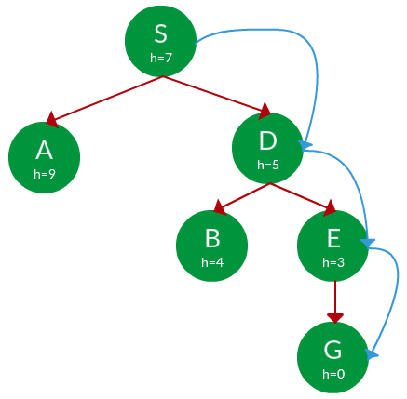
Path: S -> D -> E -> G
Advantage: Works well with informed search problems, with fewer steps to reach a goal.
Disadvantage: Can turn into unguided DFS in the worst case.

----A* Tree Search:
A* Tree Search, or simply known as A* Search, combines the strengths of uniform-cost search and greedy search. In this search, the heuristic is the summation of the cost in UCS, denoted by g(x), and the cost in the greedy search, denoted by h(x). The summed cost is denoted by f(x).
Heuristic: The following points should be noted wrt heuristics in A* search. f(x)=g(x)+h(x) f(x)=g(x)+h(x)
- Here, h(x) is called the forward cost and is an estimate of the distance of the current node from the goal node.
- And, g(x) is called the backward cost and is the cumulative cost of a node from the root node.
- A* search is optimal only when for all nodes, the forward cost for a node h(x) underestimates the actual cost h*(x) to reach the goal. This property of A* heuristic is called admissibility.
Admissibility: 0⩽h(x)⩽h∗(x) 0⩽h(x)⩽h∗(x)
Strategy: Choose the node with the lowest f(x) value.
Example:
Question. Find the path to reach from S to G using A* search.
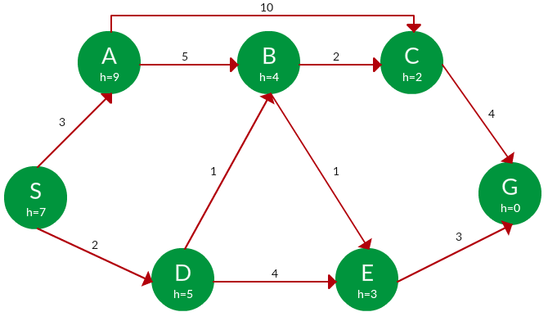
Solution. Starting from S, the algorithm computes g(x) + h(x) for all nodes in the fringe at each step, choosing the node with the lowest sum. The entire work is shown in the table below.
Note that in the fourth set of iterations, we get two paths with equal summed cost f(x), so we expand them both in the next set. The path with a lower cost on further expansion is the chosen path.
Path | h(x) | g(x) | f(x)
S | 7 | 0 | 7
S -> A | 9 | 3 | 12
S -> D | 5 | 2 | 7
S -> D -> B | 4 | 2 + 1 = 3 | 7
S -> D -> E | 3 | 2 + 4 = 6 | 9
S -> D -> B -> C | 2 | 3 + 2 = 5 | 7
S -> D -> B -> E | 3 | 3 + 1 = 4 | 7
S -> D -> B -> C -> G | 0 | 5 + 4 = 9 | 9
S -> D -> B -> E -> G | 0 | 4 + 3 = 7 | 7
Path: S -> D -> B -> E -> G
Cost: 7

--A* Graph Search:
- A* tree search works well, except that it takes time re-exploring the branches it has already explored. In other words, if the same node has expanded twice in different branches of the search tree, A* search might explore both of those branches, thus wasting time
- A* Graph Search, or simply Graph Search, removes this limitation by adding this rule: do not expand the same node more than once.
- Heuristic. Graph search is optimal only when the forward cost between two successive nodes A and B, given by h(A) - h (B), is less than or equal to the backward cost between those two nodes g(A -> B). This property of the graph search heuristic is called consistency.
Consistency: h(A)−h(B)⩽g(A→B) h(A)−h(B)⩽g(A→B)
Example:
Question. Use graph searches to find paths from S to G in the following graph.
the Solution. We solve this question pretty much the same way we solved last question, but in this case, we keep a track of nodes explored so that we don't re-explore them.
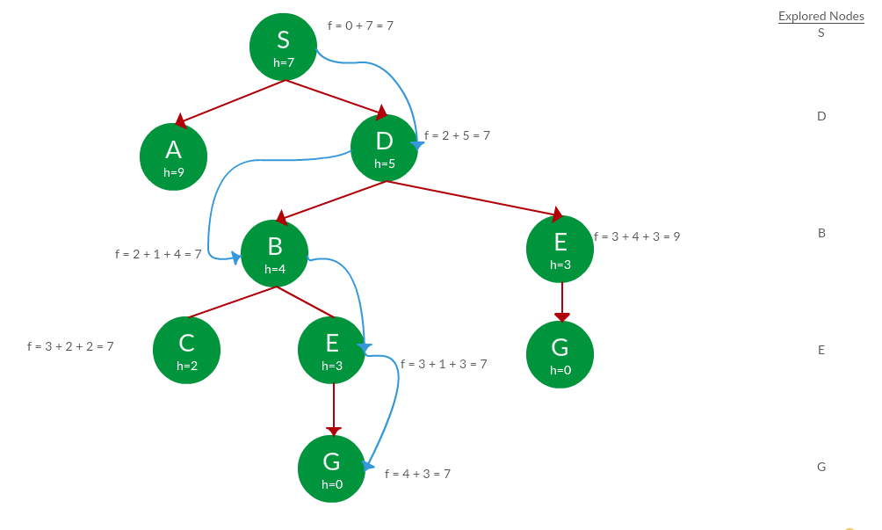
Path: S -> D -> B -> E -> G
Cost: 7

--------------------------------------------------------------------

Introduction to Heuristic Techniques
Heuristic techniques are strategies that utilize specific criteria to determine the most effective approach among multiple options for achieving a desired goal. These techniques enhance the efficiency of search processes by prioritizing speed over systematic and exhaustive exploration. Heuristics are particularly useful for solving complex problems, such as the traveling salesman problem, in a time-efficient manner, often yielding good solutions without the exhaustive computational cost of exponential-time algorithms.

Understanding Beam Search Algorithm
Beam Search is a heuristic search algorithm that navigates a graph by systematically expanding the most promising nodes within a constrained set. This approach combines elements of breadth-first search to construct its search tree by generating all successors at each level. However, it only evaluates and expands a set number, W, of the best nodes at each level, based on their heuristic values. This selection process is repeated at each level of the tree.

Characteristics of Beam Search
- Width of the Beam (W): This parameter defines the number of nodes considered at each level. The beam width W directly influences the number of nodes evaluated and hence the breadth of the search.
- Branching Factor (B): If B is the branching factor, the algorithm evaluates W×BW×B nodes at every depth but selects only W for further expansion.
- Completeness and Optimality: The restrictive nature of beam search, due to a limited beam width, can compromise its ability to find the best solution as it may prune potentially optimal paths.
- Memory Efficiency: The beam width bounds the memory required for the search, making beam search suitable for resource-constrained environments.
Example: Consider a search tree where W = 2 and B = 3. Only two nodes (black nodes) are selected based on their heuristic values for further expansion at each level.
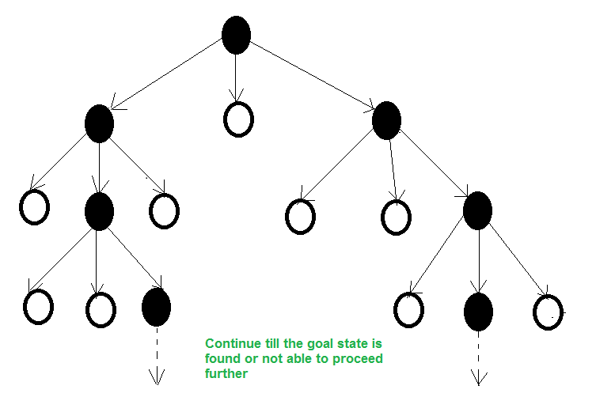Beam Search

How Beam Search Works?
The process of Beam Search can be broken down into several steps:
- Initialization: Start with the root node and generate its successors.
- Node Expansion: From the current nodes, generate successors and apply the heuristic function to evaluate them.
- Selection: Select the top W nodes according to the heuristic values. These selected nodes form the next level to explore.
- Iteration: Repeat the process of expansion and selection for the new level of nodes until the goal is reached or a certain condition is met (like a maximum number of levels).
- Termination: The search stops when the goal is found or when no more nodes are available to expand.

LEARN-ONE-RULE Algorithm: A General-to-Specific Beam Search Approach
The LEARN_ONE_RULE function is a practical implementation of beam search designed to derive a single rule that covers a subset of examples. It utilizes a general-to-specific greedy search, guided by a performance metric to identify the most effective rule.

Algorithm Execution Flow
- Start:
  - Initialize the node to Root_Node and Found to False.
- Search Loop:
  - If the current node is the goal, set Found to True.
  - Otherwise, find successors and estimate costs, storing them in the OPEN list.
  - Continuously select the top W elements from the OPEN list for expansion.
- Evaluation:
  - If the goal is found during expansion, return Yes.
  - If the search concludes without finding the goal, return No.

How the Beam Search Algorithm Works
Similar to A* search, the algorithm uses an open list and a closed list for the exploration of nodes. In this algorithm, the open list is an ordinary queue. The algorithm begins with a start node S, which also serves as the root node for the search tree.
- Initialize a search tree with the root node being the start node S. This is level zero in the tree.
- Add S to the closed list and evaluate all nodes adjacent to S.
- Select the top β nodes and add them as child nodes to S in the tree. Disregard all other nodes.
- Add the selected nodes to the open list for further exploration.
- Remove all nodes in the open list. Once a node is removed from the open list for exploration, add it to the closed list.
- Evaluate all adjacent nodes and sort them according to the evaluation function.
- Select the top β nodes and add them to the tree, connecting them to their respective parent nodes.
- Repeat this process until the goal node G is removed from the open list, indicating that a path has been found.
It is important to note that every level of the search tree contains at most β number of nodes.
Example
Consider the following example of searching a graph from S to G. For simplicity, only the edge weights will be used for evaluation. A beam width of β = 2 will be used, meaning only the top two nodes are considered at every level.
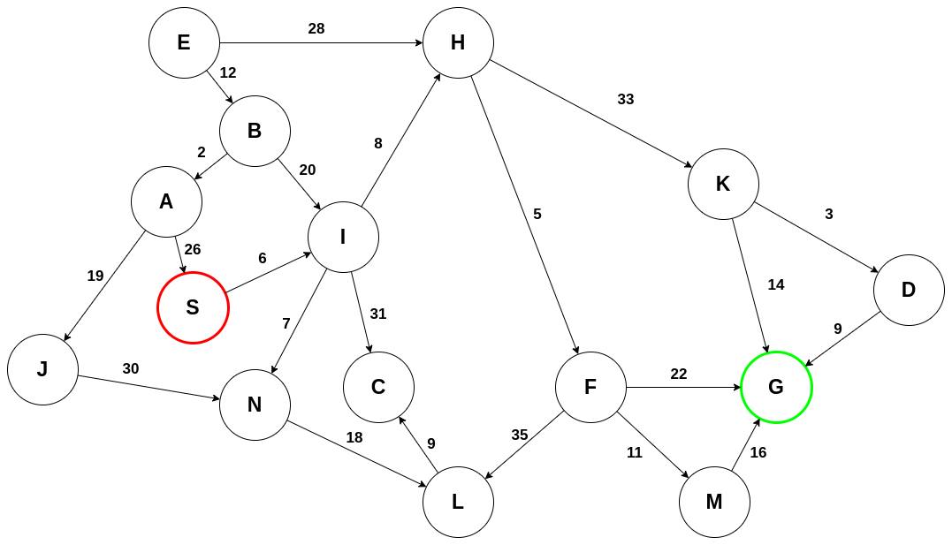
Initialize the tree and add S to the closed list:
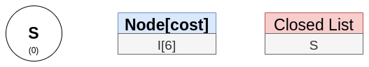
S only has one adjacent node, so it is added to the tree:
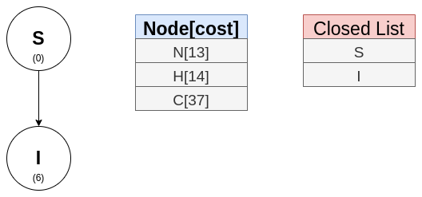
Explore I. Nodes N and H are the top two nodes, so those are added to the tree: 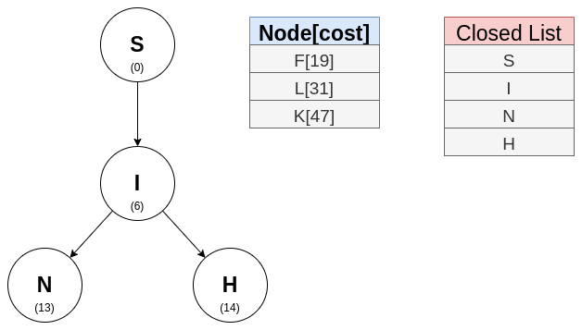
Nodes F (adjacent to H in the graph) and L (adjacent to N in the graph) are next: 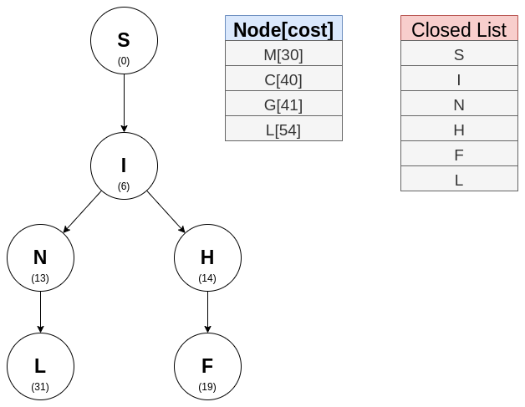
The incompleteness of this algorithm can be seen in this step. Node G has appeared in the open list but unfortunately, it has been eliminated by the beam

width. Nodes M and C are next: 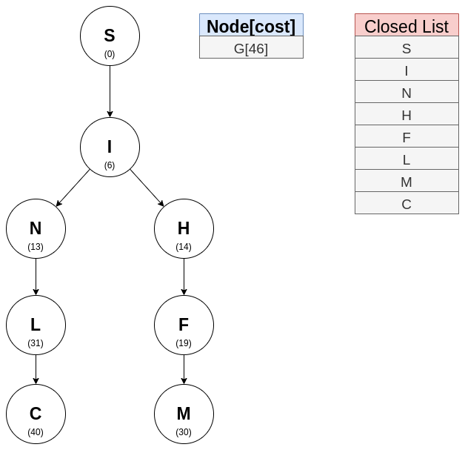
It is in this step that node G has been found: 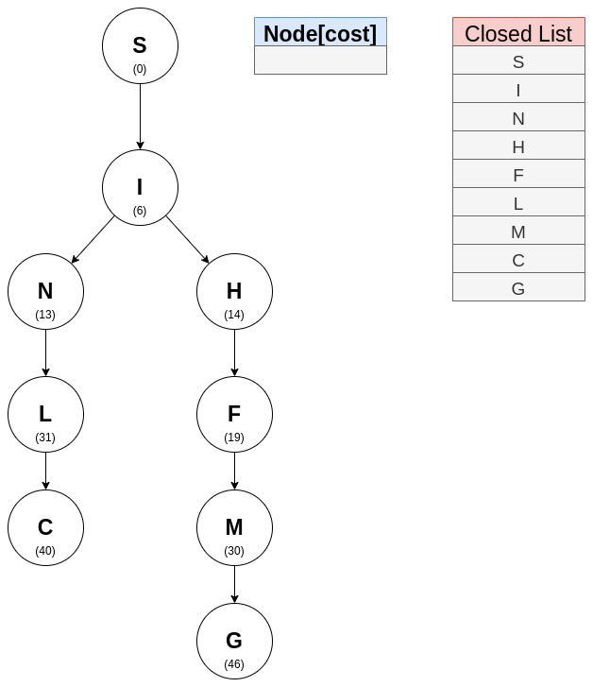
Trace the path from S to G: 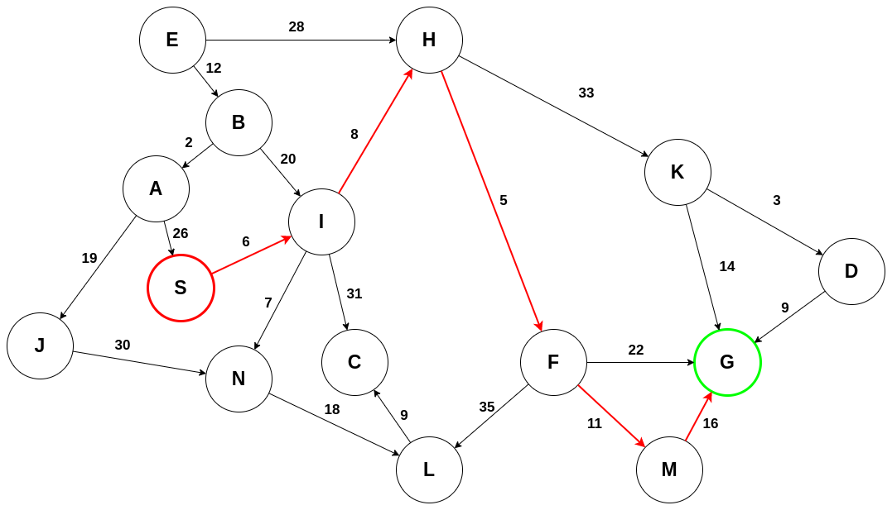
Pseudocode for Beam Search Algorithm
function BEAM_SEARCH(start_node, goal_test, beam_width, max_depth):
current_level ← [start_node]
depth ← 0

while current_level is not empty AND depth < max_depth:
all_successors ← []

// Generate all successors from current level
for each node in current_level:
if goal_test(node):
return SUCCESS (node)

successors ← get_successors(node)
for each successor in successors:
successor.score ← evaluation_function(successor)
all_successors.append(successor)

if all_successors is empty:
return FAILURE

// Sort all successors by their scores (best first)
sorted_successors ← sort(all_successors, by=score, descending=True)

// Keep only top beam_width candidates for next level
current_level ← sorted_successors[0 : beam_width]
depth ← depth + 1

// Check final level for goal
for each node in current_level:
if goal_test(node):
return SUCCESS (node)

return FAILURE

Copy to clipboard
Advantages and Disadvantages of Beam Search
As stated before, the advantage of BEAM search is that it is efficient both in time and memory. The disadvantage can be seen from the example in that a possible shortest path from S to G was overlooked. This can be somewhat corrected by varying the beam width to include more nodes. This, however, would reduce the efficiency of the algorithm. Selecting the optimal beam width is problem-specific and usually requires further insight into the problem.
Applications of BEAM Search
The BEAM search algorithm is commonly used in natural language processing and machine translation. An encoder is used to process the text from the source language and BEAM search selects the most probable words (the beam width) in the target language. The evaluation function in this context is the conditional probability of a word in the target language.

Pseudocode
LEARN_ONE_RULE(Target_attribute, Attributes, Examples, k)
Initialize Best_hypothesis to the most general hypothesis (θ)
Initialize Candidate_hypotheses to {Best_hypothesis}
While Candidate_hypotheses is not empty:
All_constraints <- Set of all constraints (a = v) where:
a ∈ Attributes
v = value of a that occurs in Examples
New_candidate_hypotheses <- Empty Set
For each h in Candidate_hypotheses:
For each c in All_constraints:
new_h <- h + c
// Create specialization of h by adding the constraint c
If new_h is not duplicate, inconsistent, and maximally specific:
Add new_h to New_candidate_hypotheses
// Evaluate and update the best hypothesis
For each h in New_candidate_hypotheses:
If PERFORMANCE(h, Examples, Target_attribute) > PERFORMANCE(Best_hypothesis, Examples, Target_attribute):
Best_hypothesis <- h
// Narrow down to the k best hypotheses
Candidate_hypotheses <- Select the k best New_candidate_hypotheses based on PERFORMANCE
// Formulate the final rule
Return "IF Best_hypothesis THEN prediction"
Where prediction is the most frequent value of Target_attribute among Examples that match Best_hypothesis

Advantages of Beam Search
- Efficiency: By limiting the number of nodes expanded, Beam Search can navigate large search spaces more efficiently than exhaustive searches.
- Flexibility: The algorithm can be adjusted for different problems by modifying the beam width and heuristic function.
- Scalability: Suitable for problems where the solution paths are vast and complex, as it does not require all nodes to be stored in memory.

Limitations of Beam Search
- Suboptimality: There is no guarantee that Beam Search will find the optimal solution, especially if the beam width is too narrow.
- Heuristic Dependency: The effectiveness of Beam Search is highly dependent on the quality of the heuristic function. Poor heuristics can lead to suboptimal searching and results.

Applications of Beam Search Algorithm in AI
Beam Search is widely used in various fields, including:
- Natural Language Processing (NLP): For tasks like machine translation and speech recognition where the goal is to find the best sequence of words or phonemes.
- Robotics: In pathfinding algorithms where a robot must find an efficient path in an environment.
- Game AI: In strategic games where it is impractical to explore every possible move due to the enormous search space.

Conclusion
This structured approach to using heuristic techniques, particularly beam search, illustrates the potential to efficiently address complex search problems by balancing between breadth of search and memory constraints. By implementing the LEARN_ONE_RULE algorithm, we can effectively navigate through complex decision spaces to find practical solutions in various domains such as machine learning and optimization.

Comment

Hill Climbing Algorithm in Artificial Intelligence
6 May 2025 | 10 min read
Hill climbing algorithm is a local search algorithm that continuously moves in the direction of increasing elevation/value
to find the peak of the mountain or the best solution to the problem. It terminates when it reaches a peak value where no
neighbor has a higher value.
It is a technique which is used for optimizing the mathematical problems. One of the widely discussed examples of
Hill climbing algorithm is Traveling-salesman Problem in which we need to minimize the distance traveled by
the salesman.
It is also called greedy local search as it only looks to its good immediate neighbor state and not beyond that.
A node of hill climbing algorithm has two components which are state and value. Hill Climbing is mostly used
when a good heuristic is available. In this algorithm, we don't need to maintain and handle the search tree or graph,
as it only keeps a single current state.
Advantages of Hill climb algorithm:
The merits of the Hill Climbing algorithm are given below.
- The first part of the paper is based on Hill's diagrams that can easily put things together, ideal for complex
optimization problem. A hill climbing algorithm is first invention of hill climbers.
- It uses much less RAM for the current problem state and the solutions located around it than comparing the
algorithm to a tree search method, which will require inspecting the entire tree. Consequently, this reduces the total
memory resources to be used. Space is what matters; solutions should occupy a convenient area to consume as little memory as possible.
- When it comes to the acceleration of the hill up, most of the time it brings a closure in the local maximum straight
away. This is the route if having quickly getting a quick solution, outshining acquiring a global maximum, is an
incentive.
Disadvantages of Hill Climbing Algorithm
- Concerning hill climbing, it seems that some solutions do not find the optimum point and remain stuck at a
local peak, particularly where the optimization needs to be done in complex environments with many objective functions.
- It is also superficial because it just seeks for the surrounding solution and does not get farther than that.
It could be on a wrong course which is based on a locally optimal solution, and consequently Godbole needs to
move far away from current position in the first place.
- It is highly likely that the end result will largely depend on the initial setup and state, with a precedent of it
being the most sensitive factor. It implies that in this case, time is the perimeter of the sphere within which people
develop their skills dynamically, determining their success.
Features of Hill Climbing:
The following are some main features of the Hill Climbing Algorithm:
- Generate and Test variant: Hill Climbing is a variant of the Generate and Test method. The Generate and Test
method produces feedback that helps to decide which direction to move in the search space.
- Greedy approach: Hill-climbing algorithm search moves in the direction that optimizes the cost.
- No backtracking: It does not backtrack the search space, as it does not remember the previous states.
- Deterministic Nature: Hill Climbing is a deterministic optimization algorithm, which means that given the same
initial conditions and the same problem, it will always produce the same result. There is no randomness or uncertainty in its operation.
- Local Neighborhood: Hill Climbing is a technique that operates within a small area around the current solution.
It explores solutions that are closely related to the current state by making small, gradual changes. This approach
allows it to find a solution that is better than the current one, although it may not be the global optimum.
State-space Diagram for Hill Climbing:
The state-space landscape is a graphical representation of the hill-climbing algorithm which is showing a graph between
various states of algorithm and Objective function/Cost.
On Y-axis we have taken the function which can be an objective function or cost function, and state-space on the x-axis.
If the function on Y-axis is cost then, the goal of search is to find the global minimum and local minimum. If the function
of Y-axis is Objective function, then the goal of the search is to find the global maximum and local maximum.
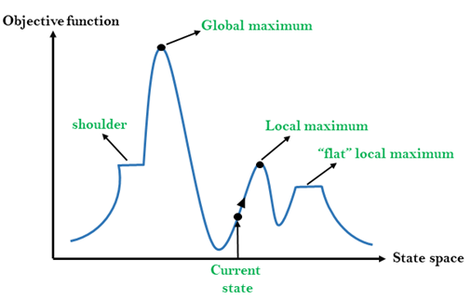
Different regions in the state space landscape:
- Local Maximum: Local maximum is a state which is better than its neighbor states, but there is also another state
which is higher than it.
- Global Maximum: Global maximum is the best possible state of state space landscape. It has the highest value of
objective function.
- Current State: It is a state in a landscape diagram where an agent is currently present.
- Flat local maximum: It is a flat space in the landscape where all the neighboring states of the current state have
the same value.
- Shoulder: It is a plateau region that has an uphill edge.
Types of Hill Climbing Algorithm:
- Simple hill Climbing:
- Steepest-Ascent hill-climbing:
- Stochastic hill Climbing:
1. Simple Hill Climbing:
Simple hill climbing is the simplest way to implement a hill-climbing algorithm. It only evaluates the neighbor node state
at a time and selects the first one that optimizes the current cost, and sets it as the current state. It only checks its one
successor state, and if it finds a better state than the current state, then it moves, else it remains in the same state. This
algorithm has the following features:
- Less time-consuming
- A less optimal solution, and the solution is not guaranteed
Algorithm for Simple Hill Climbing:
- Step 1: Evaluate the initial state. If it is the goal state, then return success and Stop.
- Step 2: Loop until a solution is found or there is no new operator left to apply.
- Step 3: Select and apply an operator to the current state.
- Step 4: Check the new state:
  - If it is the goal state, then return success and quit.
  - Else if it is better than the current state, then assign the new state as the current state.
  - Else if not better than the current state, then return to step 2.
- Step 5:
2. Steepest-Ascent hill climbing:
The steepest ascent algorithm is a variation of the simple hill climbing algorithm. This algorithm examines all the
neighboring nodes of the current state and selects one neighbor node that is closest to the goal state. This algorithm
consumes more time as it searches for multiple neighbors.
Algorithm for Steepest-Ascent hill climbing:
- Step 1: Evaluate the initial state. If it is the goal state, then return success and stop; else make the current state
as initial state.
- Step 2: Loop until a solution is found or the current state does not change.
  - Let SUCC be a state such that any successor of the current state will be better than it.
  - For each operator that applies to the current state:
    - Apply the new operator and generate a new state.
    - Evaluate the new state.
    - If it is the goal state, then return it and quit; else, compare it to the SUCC.
    - If it is better than SUCC, then set the new state as SUCC.
    - If the SUCC is better than the current state, then set the current state to SUCC.
- Step 5:
3. Stochastic hill climbing:
Stochastic hill climbing does not examine for all its neighbor before moving. Rather, this search algorithm selects one
neighbor node at random and decides whether to choose it as a current state or examine another state.
Hybrid Methods
Although Hill Climbing Algorithm is a very efficient and useful local search technique, there are several drawbacks
including plateaus, ridges, and local maxima trapping. To surpass these limitations and produce better optimization solutions, experts and practitioners usually employ hybrid approaches combining hill climbing with other algorithms addressing its
shortcomings.
1. Hill climbing combined with simulated annealing
Controlled randomness is introduced into the search process using a technique called simulated annealing. Simulated
annealing rejects states with poorer fitness according to a random probability function; hill climbing only rejects ones that
improve fitness (in this case, a higher value). Simulated annealing can push through a local peak if hill climbing reaches
one by accepting a small value drop, and allow the search to explore other areas of the solution space.
2. Mountain Climbing and Genetic Algorithms
Mutation, crossover, and selection are three types of techniques used by genetic algorithms (GAs). Hill climbing is one
local optimizer in genetic algorithms. After a new one is created with crossover and mutation, hill climbing can be
employed to iterate or &quot; polish" that solution for enhancement. Together, GAs provide great better quality solution
and faster convergence time; hill climbing local search together can.
3. Memetic Algorithms' Hill Climbing
Sophisticated hybrids of evolutionary algorithms, memetic algorithms combine other kinds of individual learning or local
search with local refining methods like hill climbing. Before it enters the next generation, every candidate solution in
Memetic Algorithms is subject to local improvement by hill climbing. Since this method is balanced, the search process is
more intelligent: the GA permits exploration (by random search for mutations and crossover) and the hill climbing provides the exploitation (by local search).
Problems in Hill Climbing Algorithm:
  - Local Maximum: A local maximum is a peak state in the landscape which is better than each of its
neighboring states, but there is another state also present which is higher than the local maximum.
Solution: Backtracking technique can be a solution of the local maximum in state space landscape. Create a list of the
promising path so that the algorithm can backtrack the search space and explore other paths as well.
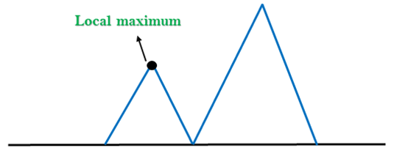
  - Plateau: A plateau is the flat area of the search space in which all the neighbor states of the current state contain the
same value, because of this algorithm does not find any best direction to move. A hill-climbing search might be lost in the plateau area.
Solution: The solution for the plateau is to take big steps or very little steps while searching, to solve the problem.
Randomly select a state which is far away from the current state so it is possible that the algorithm could find non-plateau region.
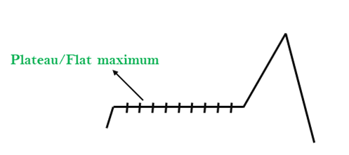
  - Ridges: A ridge is a special form of the local maximum. It has an area which is higher than its surrounding areas, but it
has a slope, and cannot be reached in a single move.
Solution: With the use of bidirectional search, or by moving in different directions, we can improve this problem.
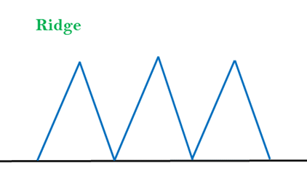
Simulated Annealing:
A hill-climbing algorithm that never makes a move towards a lower value is guaranteed to be incomplete because it can
get stuck on a local maximum. And if algorithm applies a random walk, by moving a successor, then it may complete but
not efficient. Simulated Annealing is an algorithm which yields both efficiency and completeness.
In mechanical terms, Annealing is a process of hardening a metal or glass to a high temperature, then cooling gradually, so
this allows the metal to reach a low-energy crystalline state. The same process is used in simulated annealing, in which the
algorithm picks a random move, instead of picking the best move. If the random move improves the state, then it follows
the same path. Otherwise, the algorithm follows the path that has a probability of less than 1, or it moves downhill and
chooses another path.
Applications of Hill Climbing Algorithm
The hill-climbing technique has seen widespread usage in artificial intelligence and optimization, respectively. It
methodically solves those problems via coupled research activities by systematically testing options and picking out the
most appropriate one. Some of the applications are as follows:
Some of the application are as follows:
1. Machine Learning:
Fine tuning of machine learning models frequently is doing the hyper parameter optimization that provides the model with
guidance on how it learns and behaves. Another exercise which serves the same purpose is hill training. Gradual
adjustment of hyperparameters and their evaluation according to the respectively reached the essence of the hill climbing
method.
2. Robotics:
In robotics, hill climbing technique turns out to be useful for an artificial agent roaming through a physical environment
where its path is adjusted before arriving at the destination.
3. Network Design:
The tool may be employed for improvement of network forms, processes, and topologies in the telecommunications
industry and computer networks. This approach erases the redundancy thus the efficiency of the networks are increased by
studying and adjusting their configurations. It facilitates better cooperation, efficiency, and the reliability of diverse
communication system.
4. Game playing:
Altough the hill climbing can be optimal in game playing AI by developing the strategies which helps to get the maximum
scores.
5. Natural language processing:
The software assists in adjusting the algorithms to enable the software to be efficient at dealing with the tasks at hand such
as summarizing text, translating languages and recognizing speech. These abilities owing to it as a significant tool for many applications.
Implementation
Now we will try to maximize the function with the help of the Hill Climbing algorithm: f (x) = -x² + 5
Code:
- # Importing the libraries
- import random
- import matplotlib.pyplot as plt

- # Defining the function to maximize
- def function_target(val):
- return -val**2 + 5 # A parabola with maximum at x = 0

- # Visualizing the hill-climbing algorithm
- def hill_climbing_with_plot(
- steps_max=1000, step_range=0.1, x_min=-10, x_max=10
- ):
- # Starting with some random solution
- point_current = random.uniform(x_min, x_max)
- value_current = function_target(point_current)

- # Tracking the progress for the purpose of visualization
- history_x = [point_current]
- history_y = [value_current]

- for step in range(steps_max):
- # Generating a neighboring point by adding a small random step
- point_neighbor = point_current + random.uniform(-step_range, step_range)

- # Ensuring that the neighbor stays within limits
- point_neighbor = max(min(point_neighbor, x_max), x_min)
- value_neighbor = function_target(point_neighbor)

- # If the neighbor is better, move to it
- if value_neighbor > value_current:
- point_current = point_neighbor
- value_current = value_neighbor

- # Recording the current best point
- history_x.append(point_current)
- history_y.append(value_current)

- return point_current, value_current, history_x, history_y

- # Running the algorithm
- opt_x, opt_y, path_x, path_y = hill_climbing_with_plot()

- # Getting the final result
- print(f"Optimal x: {opt_x:.4f}, f(x): {opt_y:.4f}")

- # Plotting the function and the hill climbing path
- x_vals = [x / 100.0 for x in range(-1000, 1000)]
- y_vals = [function_target(x) for x in x_vals]

- plt.figure(figsize=(10, 6))
- plt.plot(x_vals, y_vals, label="Target Function: f(x) = -x² + 5", color='blue')
- plt.plot(path_x, path_y, marker='o', color='red', label='Search Path')
- plt.title("Hill Climbing Optimization Path")
- plt.xlabel("x")
- plt.ylabel("f(x)")
- plt.legend()
- plt.grid(True)
- plt.show()
- <textarea>
Output:
Optimal x: -0.0001, f(x): 5.0000
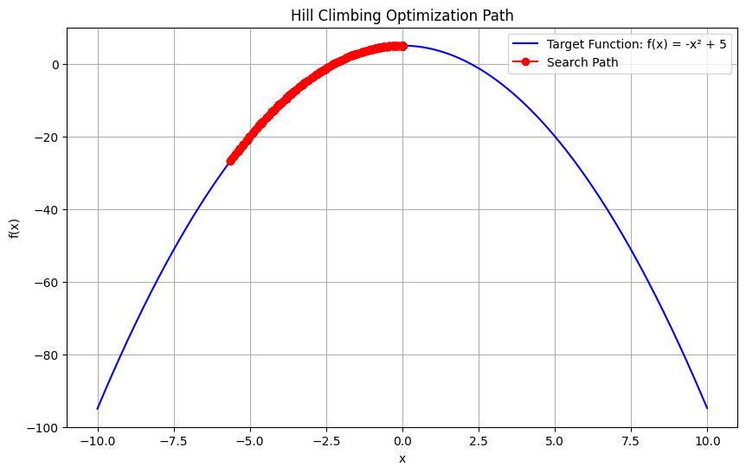
This shows the algorithm has found a value of x close to 0, where the function achieves its maximum.

